# File System Task (Eight Task create)

# Create SSIS package for below functionalities.

# This is the initial source folder

# This is the initial Target folder

# 1. Copy:---Copy file from source path to achieve path

# The file has been copied to the destination folder

# The data flow was also executed

# 2. Move:---move file from source path to achieve path(Deleted file in source path)

# I have selected ft2 file as FLAT2 for the flat file source

# The file was moved from source folder to the target folder

# The data flow task was also executed

# 3. Delete: Delete file from source path

# I have selected ft3 file as FLAT3 for the flat file source

# The file ft3 was deleted

# The data flow task was also executed

# 4. Copy Directory

# I have selected ft4 file as FLAT4 for the flat file source

# I copied some more files into the source folder

# The destination folder before executing the package

# The destination folder after executing the package

# 5. Create Directory

# 6. Delete Directory

# The file named SYSTEM_FILE_TASK_SOURCE is deleted

# 7. Move Directory

# I created a new folder for source

# Rename File

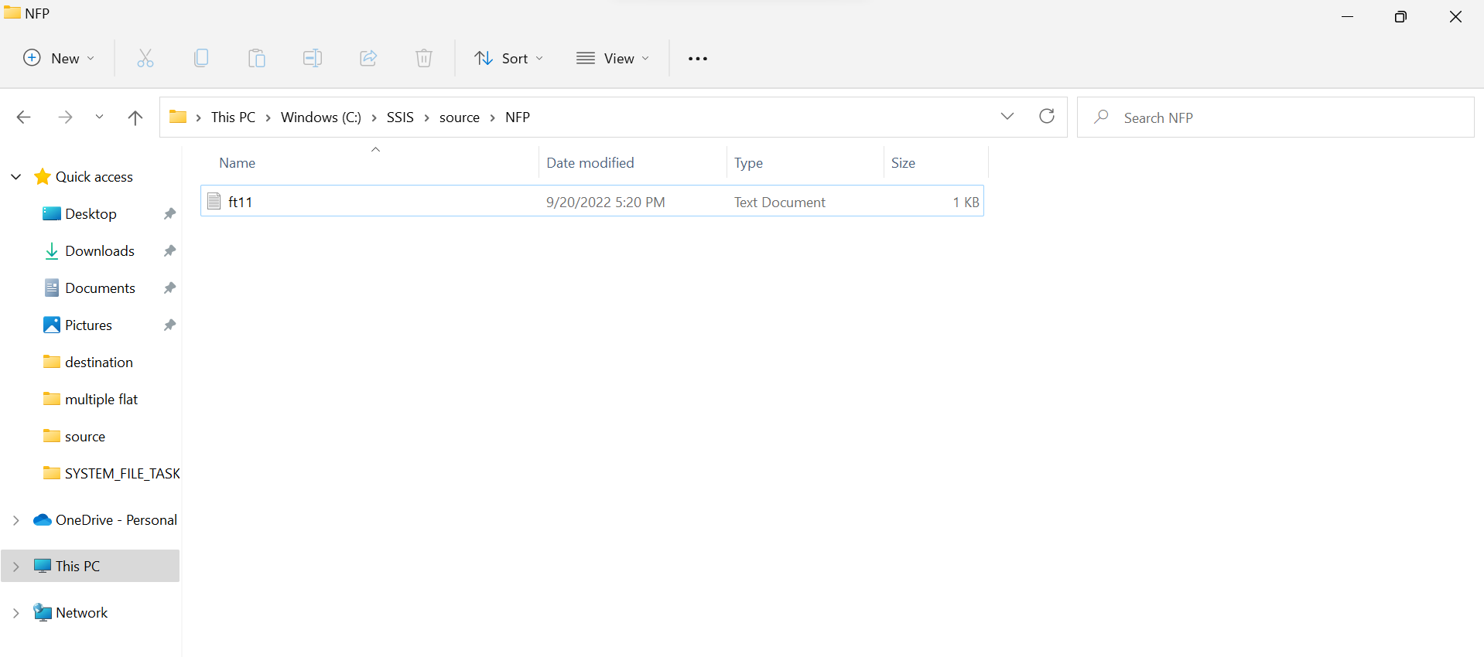

The name of the folder is changed to new name

